Ethics in IT

Class 8
Lab 1

Lab Objectives:

Basic of Ethics

Introduction to Ethics
In our present age, ethics has an important place in all areas of life. Ethics has also become important in education, because education is a fundamental process of human life.



Therefore, ethics is very important subject in education. We can easily reach all knowledge by technology.

In education using technology reveals some ethical problems such as plagiarism.

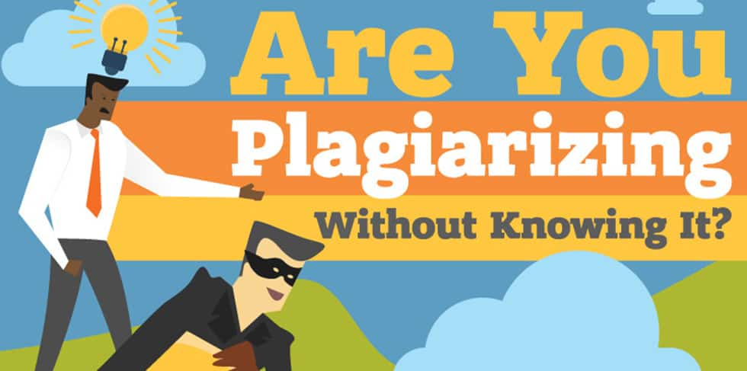

In order to understand the importance of ethics, ethics should be placed as a course in educational system.


Before discussing this issue, it is necessary to define what ethics is and what education is. Ethics is the most important and functioning branch of philosophy in today.

In general, ethics is moral philosophy. The term ethics is derived from Greek term Ethos which means custom, character. It is related to our values and virtues.


Therefore, our actions and our experiences in everyday life are the subjects of ethics. We have the capacity to think about our choices, so we are responsible for all our decisions and actions.



In addition to this, it can be said that ethics is the study of what is wrong and what is right. Good-evil, right-wrong, virtue- vice, justice and injustice are some ethical concepts.

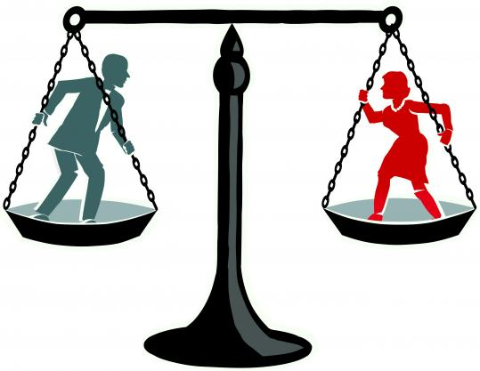

Ethics is divided into two parts: theoretical ethics and applied ethics.
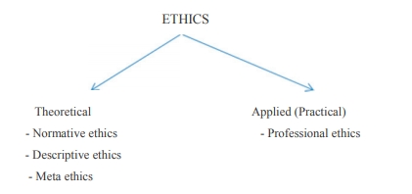

Normative ethics is the study of what makes actions right and wrong.

Meta ethics is about the theoretical meaning and reference of moral propositions.

Descriptive ethics is about facts. It examines ethics from observations of actual choices made by moral agents in practice Applied ethics examines the particular ethical issues of private and public life.

Professional ethics is one of the important branches of applied ethics. In general professional ethics can be defined as standards or codes to provide people to guidance in their professional lives.

The role of ethical education

Ethics education can be divided into four stages:

Ethics education in family

Ethics education in school

Ethics education in university

Ethics education in business

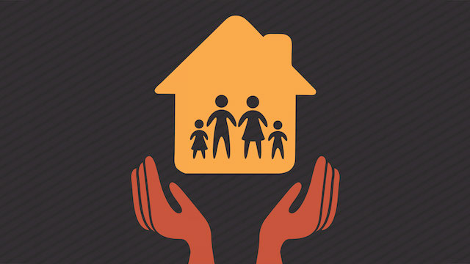
In family, ethics education should focus on descriptive facts. Children observe their parents’ (role models) ethical behaviors and they learn social facts about ethical behaviour.

In school, students learn what is right and what is wrong. This is a value education or character education. In educational systems, generally ethics is associated with religion. Therefore, instead of ethics course students take religious course. However, students should learn values clarification, and making ethical decision. In addition, school fosters to students become trustful, responsible, and just person. Ethics in school can benefit to this.

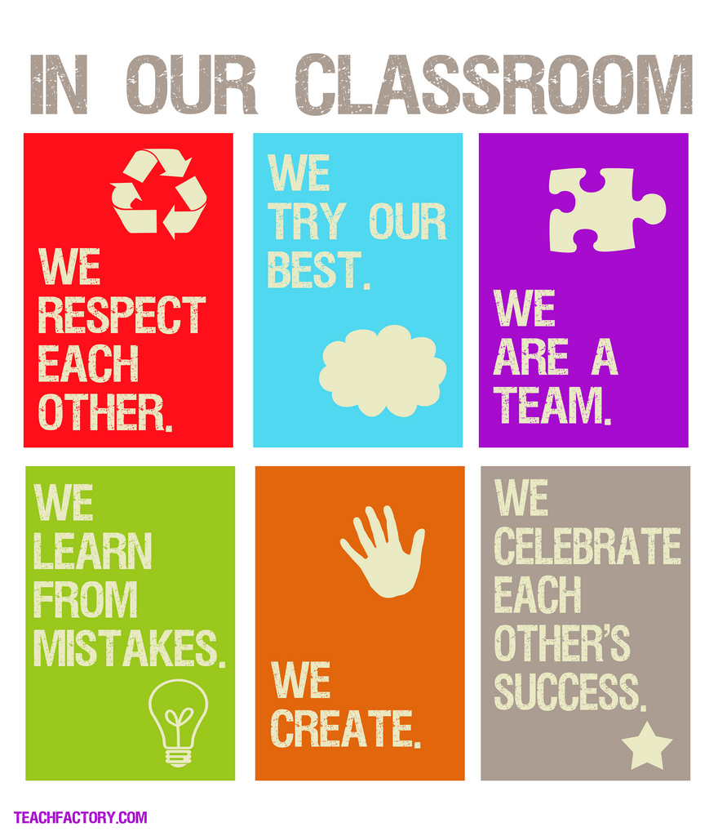

In university, ethics should be professional ethics. Only some students can take ethics course related to their professions in universities, because in universities ethics does not give as a course in all departments.

This kind of ethical education provides students to realize what is right, make good decisions about ethical issues in their professions.

